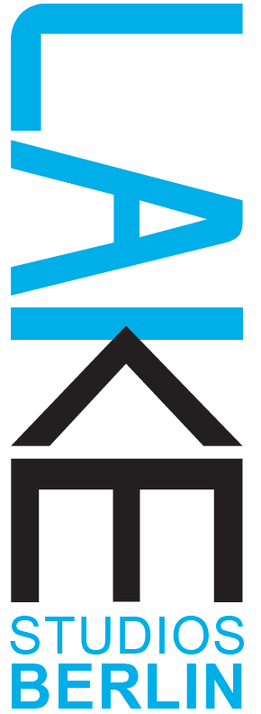

OPEN CALL:
SUBMERGE Summer Festival — dive into the rhythm
at LAKE Studios Berlin | Dance Research Residency Center

From July 29th to September 1st, 2024, LAKE Studios Berlin will host the sixth volume of the SUBMERGE Festival — celebrating choreography and artistic solidarity. The festival consists of workshops taught as precursors to performances. The workshops function as "re-creative" labs where artists guide participants into the crafting of their work. Each workshop includes a formal performance of the piece investigated in the lab.

For the 2024 Submerge program, we are seeking finished performance works that explore the intersections of (live) music and dance. We are particularly interested in artists and works that give voice to underrepresented cultural expressions in the German contemporary dance and performance scene.

OUR CALL:
We are looking for finished pieces — solos, duets or trios — 30 to 40 minutes in length, to be presented in an evening or afternoon double-bill with another artist's work. We will also give consideration to durational pieces or installations designed for public spaces.
Artists must be willing to offer a two-day workshop, The Choreographer's LAB, to introduce their work processes to other professional performance artists. Workshops will take place from 11:00 - 16:00 on two consecutive days. Chosen pieces will be presented either the week of August 5th, August 19th, or the week of August 26th. Artists must be based in Berlin.

THEME: Pleasure and Groove, Rhythm and Resistance

“We need to learn how to practice love such that care—for ourselves and others—is understood as political resistance and cultivating resilience.”
Adrienne Maree Brown, Pleasure Activism: The Politics of Feeling Good

This year's SUBMERGE Festival will highlight the confluence of music and dance, and their joint potential to foster joy, strength, resistance and resilience.

We will consider works connecting (live) music and dance that address any of these questions:
Do you have a finished work that holds at its center the relationship between music, rhythm and dance? A piece that explores the philosophical potential of rhythm, the musical body, the gratification of dance performed with live music, and/or the risks and rewards of presenting the dance-inherent-in-music and the-music-inherent-in-dance? Does your work fit the guiding quote above? Does it explore activism via tools of music and dance?
Is your work engaged with underrepresented dance and music within the German contemporary dance and performance scene?
Does your work celebrate the joyful power of performance and challenge us to think critically or act with awareness in the face of adversity?

The SUBMERGE Festival will take place in barrier free studios.

WHAT WE OFFER:

- Two-day Workshop 500€ for one facilitator
- Performance 350€ per artist
- Light and tech support for performance
- Professional video and photos of performance
- Child care support during workshop and performance
- Accessibility support
- 4 hours of Studio time in July or August

To apply, use the application form available for download on our website. Applications can be submitted in German or English. Email complete forms to submergefestival@gmail.com.

APPLICATION DEADLINE: May 15th

