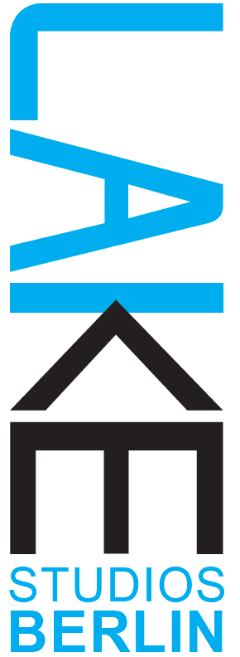

Lake Studios Berlin | 10 Year Anniversary Festival
Application Form - Unfinished Fridays JUNIOR
Please fill out this form and, together with your CV and the CVs of your collaborators, send by e-mail to:
residency@lakestudiosberlin.com
Please use the subject line ‘UF JUNIOR Application”
Proposed title of the work – in - progress: _______________________
Proposed length of the work (between 10 – 20 mins):
Personal details:
Name:
Address :
Is a member of your team able to teach in German: YES / NO Can you write an invoice?: YES / NO
Telephone:
Email:
Website/s:

Please fill out and answer all the questions below taking care to observe the word limit.
1) Artist Statement: A short artist statement about how you define, perceive and contextualize your work as a choreographer. (No more than 200 words)

2) The performance (no more than 1800 characters):
Please use this space to share with us what interests you about making a work for children? Please share a proposal for the work which you would like to develop in residency at LAKE Studios. Make sure to let us know if the work is intended for children ages 3 – 6 or 7 – 12. Let us know what stage the work is in at this moment (just a concept, already started, already presented) – note: works at all stages in the process are welcome to apply! Please tell us shortly about your collaborating artists. Also include a brief proposal for a movement workshop/warm-up related to the piece (no more than 40 mins) that you would give to the children before the showing. Let us know of any special needs or technical requirements.

3) Links to video/documentation of 2 - 3 past works (not all must be dance/performance works – i.e film or photography, visual art can be also included here):
4) Number of dancers/performers ___. Number of other collaborators (please specify their roles) ___.

5) The work you propose is for children aged 3 – 6 or 7 – 12?

6) Are you available to perform on the 20.6. and / or the 21.6.2023?

7) Please let us know which of the following weeks you are available for the residency (can be more than one): 5.6. – 11.6. and/or 11.6. – 19.6.2023

8) How many people would need accommodation during the residency/performance days?

9) Where would you/your collaborators be traveling from if not based in Berlin?

10) Any additional information that you would like to share (not required):

We look forward to receiving your application (deadline 8.04.2023)
and will be in touch within 2 weeks to let you know about the results.
Thank you, Marcela Giesche and the LAKE Team!

