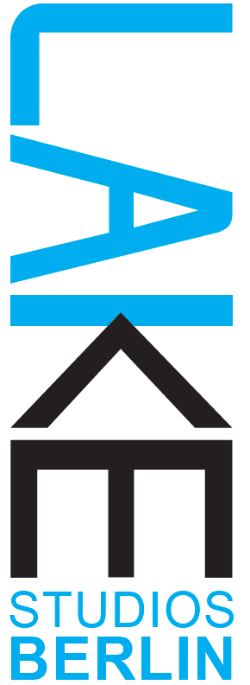

Lake Studios Berlin | 10 Year Anniversary Festival
Application Form - Unfinished Fridays # 91 – 100
Please fill out this form and, together with your CV, the CVs of your collaborators, and 2 – 3 photos related to the work, send by e-mail to:
unfinishedfridays@lakestudiosberlin.com
Please use the subject line ‘UF 91 - 100 Application”
Title of the work (in progress): _______________________
Length of the work/excerpt (between 5 – 20 mins):
Personal details:
Name:
Address :
Are you based in Berlin as a choreographer: YES / NO Are you able to write an invoice?: YES / NO
Telephone:
Email:
Website/s:

Please fill out and answer the questions below taking care to observe the word limit.
1) Artist Statement: A short artist statement about how you define, perceive and contextualize your work as a choreographer. (No more than 200 words)

2) The performance (no more than 1200 characters):
Please use this space to shortly describe your proposed work in progress.
Let us know of any special needs or technical requirements.
Please let us know if and how you would like to share elements of this work in our shared practice workshops.
The link to video material of the work, or excerpts of the work if you have it.

3) Links to video/documentation of 2 - 3 past works (not all must be dance/performance works – i.e film or photography, visual art can be also included here):

4) Number of dancers ___. Number of other collaborators (please specify their roles) ___.

5) Please specify which of the following dates you are available (can be more than one)
22.6., 23.6., 24.6. 26.6., 27.6., 28.6. 29.6., 30.6.

6) Would you like to teach a shared practice workshop related to your work (not required): YES/ NO

7) Any additional information that you would like to share (not required):

We look forward to receiving your application (deadline 8.04.2023)
and will be in touch within 2 weeks to let you know about the results.
Thank you, Marcela Giesche and the LAKE Team!

