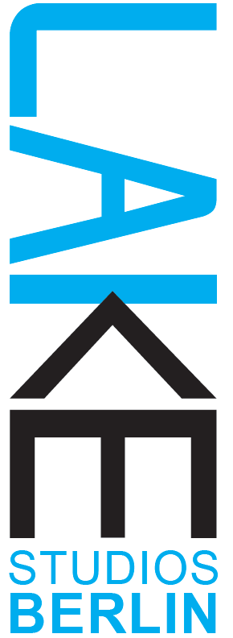

Lake Studios Berlin | DEC 2022 & FEB 2023 residencies
Application Form - Residenzförderprogram MADE IN BERLIN
Please fill out this form and, together with your CV and the CVs of your collaborators, send by e-mail to:
residency@lakestudiosberlin.com
Please use the subject line ‘DEC 2022 & FEB 2023 Residency Application”
Title of the Project: _______________________
Themes (please choose one of the three): _____________________
Personal details:
Name:
Address :
Are you registered officially in Berlin: YES / NO Are you able to write an invoice?: YES / NO
Telephone:
Email:
Website/s:

Please fill out and answer the questions below taking care to observe the word limit.
1) Artist Statement: An artist statement about how you define, perceive and contextualize your work as a choreographer. (No more than 200 words) – please note, this is an artistic statement, not a short biography or piece description.

2) The residency:
Please use this space to briefly explain your interest in the residency at LAKE Studios. Please explain clearly the following: (No more than 500 words please.)
- your proposed research and way of working
- any methods you would like to use connect and communicate with audiences and collaborators during your process
- an idea or proposal for a sharing of the work in progress (must not be finished work)
- do you have any special needs or technical requirements?

3) Links to video/documentation of 2 - 3 past works (not all must be dance/performance works – i.e film or photography, visual art can be also included here):

4) Accommodation request:
a double room / a single room / either is fine / do not necessarily need a room / wish to live off site

5) Please specify which of the periods you are available (can be more than one) 4.12.2022 – 8.1.2023, 29.1.2023 – 1.3.2023

6) Any additional information that you would like to share (not required):

We look forward to receiving your application (deadline 31.08.2022)
and will be in touch within 2 weeks to let you know about the results.
Thank you, Marcela Giesche and the LAKE Team!

